

**W14392**

**INFORMATION SYSTEM STRATEGY AT NEELKANTH DRUGS**

*Susmi Routray, Rajendra Nargundkar, Shweta Saini and Reema Saxena wrote this case solely to provide material for class discussion. The authors do not intend to illustrate either effective or ineffective handling of a managerial situation. The authors may have disguised certain names and other identifying information to protect confidentiality.*

*This publication may not be transmitted, photocopied, digitized or otherwise reproduced in any form or by any means without the permission of the copyright holder. Reproduction of this material is not covered under authorization by any reproduction rights organization. To order copies or request permission to reproduce materials, contact Ivey Publishing, Ivey Business School, Western University, London, Ontario, Canada, N6G 0N1; (t) 519.661.3208; (e)* [*cases@ivey.ca;*](mailto:cases@ivey.ca)[*www.iveycases.com.*](http://www.iveycases.com/)

*Copyright © 2014, Richard Ivey School of Business Foundation Version: 2014-08-22*

Pramod K. Sharma, the chief executive officer (CEO) of Neelkanth Drugs Pvt. Ltd. (NDPL), was pensive. It was January 2013, and he was flipping through the papers given to him by his head of information technology (IT), Manoj Kashyap. These papers contained proposals for enterprise resource planning (ERP) implementation at NDPL, one of the leading pharmaceutical distributors in Delhi, as the company was planning expansion across wider areas. The dynamic nature of the business and highly information- centric operations made it imperative for this small- and medium-scale enterprise (SME) to implement ERP.

Kashyap had prepared a report on the various ERP solutions available to NDPL, and he had presented it to Sharma. According to Kashyap’s analysis, cloud-based ERP was the best solution among the various available choices, but the CEO remained dubious because of a previous unsatisfactory cloud experience in which a great deal of confusion had ensued when the company hired a facilitator to handle the conversion for its 47 retail outlets. Huge costs had been paid, and NDPL’s business had spiraled out of control. Reverting to the prior system had entailed an additional huge cost, and it was six months before the systems at NDPL were under control again. The stakes were higher in the wholesale business than in retail, and switching between strategies was difficult. The CEO was therefore contemplating whether it would be the right decision to implement cloud-based ERP, or whether NDPL should seek out an alternative that might be less economical but also less risky.

**COMPANY BACKGROUND OF NEELKANTH DRUGS PVT. LTD.**

NDPL was one of the leading pharmaceutical distributors in Delhi, having a distribution network that included 95 per cent of the companies operating in India. The company became ISO 9001:2000 certified in January 2007 and also maintained a CRISIL rating of SME2.1 Distribution was widespread across the Indian states of Delhi and Uttar Pradesh (UP), but the company was planning to soon expand to the state of Punjab.

*1 CRISIL is a global analytical company that provides ratings, research and risk and policy advisory services. Based on the financial strength and performance capabilities of a small or medium enterprise (SME), CRISIL SME ratings are given. A CRISIL SME rating reflects the level of creditworthiness of the SME. SME2 indicates high creditworthiness.* [*www.crisil.com/ratings/crisil-sme-ratings.html,*](http://www.crisil.com/ratings/crisil-sme-ratings.html) *accessed June 9, 2014.*

The company was incorporated as NDPL in 2000, and was promoted by with G.L. Sharma and V.P. Saini. The management of the company was further augmented by the joining of P.K. Sharma during the 2003-2004 financial year. NDPL was the sister company of M/s Dhruv Medicos Pvt. Ltd. and served as the clearing and forwarding agent (CFA) for H&H Pharmaceuticals, Sante Mernaud, and Avera. NDPL was the single vendor of Apollo in Delhi and UP, and it was known to source the highest-quality drug products at the best prices. Its motto was to deliver exceptional value and customer service by supplying difficult-to-acquire drugs, thereby resolving drug shortage problems. The company had a staff of 205 employees, all of whom worked with the degree of dedication that was vital to NDPL’s growth and reputation. NDPL operated 47 retail outlets in Delhi and the National Capital Region (NCR),2 and these outlets were well connected with the central server. The organizational structure of NDPL is given in Exhibit 1.

The company’s turnover was INR 1,670,000,000 (US$26.61 million) in 2011, and this amount reached INR 2,420,000,000 (US$38.56 million) in 2013. Information systems aided the steady growth of NDPL, which was occurring at a rate of 30 per cent. NDPL had a fully computerized network for controlling inventory and sales management, along with a dedicated department for handling payments/collections and accounts reconciliation. The company was well connected, with suppliers throughout its dedicated supply chain.

**PHARMACEUTICAL DISTRIBUTION AND RETAIL INDUSTRY STRUCTURE**

The Indian pharmaceutical industry was on the verge of becoming a major global market with the potential to grow at an accelerated 15 to 20 per cent compound annual growth rate between 2010 and 2020 to reach between US$49 billion to US$74 billion in 2020.3 The pharmaceutical distribution system experienced a paradigm shift during the 1990s. Whereas in the past, the manufacturer used to own and control the warehousing facilities, this duty was taken over by CFAs in the 1990s. CFAs took care of the storing and forwarding of stocks for the stockists, in accordance with the latter’s requirements. According to an exclusive agreement between CFAs and manufacturers, the CFAs were bound to follow distribution policies, as defined by the companies.

In Western countries, a manufacturer could supply goods directly at the retail level, but in India, drug distribution used a more layered and regulated approach, owing to a multitude of factors (e.g., geography, lack of good infrastructure, individual entrepreneurship, an unorganized market, SME operation on an individual level, lack of capital, and strong trade associations). These layers were made up of the pharmaceutical manufacturers, the CFAs/super-stockists, wholesalers, and retailers. In India, product movement began with the manufacturer and then continued on to the CFA, a super-stockist or a company- owned depot. From there, the products passed to the next level, which consisted of the stockists, who further supplied the wholesalers (e.g., NDPL), hospitals, and other institutions. From the wholesaler, products were passed on to the retailers and then to the end consumers. Alternatively, a manufacturer, CFA or stockist could directly supply products to medical institutions or hospitals, but not to retailers4 (see Exhibit 2).

*2 National Capital Region - in India, this is a name for the metropolitan area that encompasses all of Delhi, as well as the surrounding urban areas in the neighbouring states of Haryana, Uttar Pradesh and Rajasthan.*

*3 Sujay Shetti and Jai Hiremath, “India Pharma Inc.: Capitalising on India’s Growth Potential,” pp. 1-27,* [*www.pwc.in/assets/pdfs/pharma/PwC-CII-pharma-Summit-Report-22Nov.pdf,*](http://www.pwc.in/assets/pdfs/pharma/PwC-CII-pharma-Summit-Report-22Nov.pdf) *accessed July 7, 2014.*

*4 “Drug Distribution Channels,” domain-b.com, January 1, 2000, www.domain-*

*b.com/industry/pharma/20000107distribution_channels.html, accessed July 7, 2014.*

**Stockists/Wholesalers**

In general, stockists marketed the products of six to eight pharmaceutical companies. The number of stockists per company had doubled in recent years, owing to the mergers and acquisitions of pharmaceutical companies, which in turn led to increased competition at the distribution level. Stockists of the same company’s products competed with each other, thereby strengthening the bargaining position of the retailers. The stockists employed visiting salesmen, who contracted and stock retailers, and the estimated number of stockists in India stood at around 70,000.5

**Retailer**

In addition to CFAs and stockists, the remainder of the market consisted of numerous traditional and modern retailers, who often acted as prescribers and retailers. Industry sources claimed that retailers accounted for approximately 70 to 80 per cent of pharmaceutical sales in India.6 The retailers ran various kinds of operations, ranging from small shops to chain enterprises. The former were often family-run firms, with a single owner or a set of brothers continuing a long-standing family tradition. Retail pharma chains were relatively new in India and had generated considerable conflict with the existing retailers. These new age, one-stop-shop chains (e.g., Apollo, Health Glow, Fortis Healthcare) have begun to offer over-the-counter drugs, health supplements, health foods, alternate medicines, and home and personal- care products. They operated around the clock and offered extended value-added services, such as free home delivery, loyalty programs, etc.

The future of Indian pharmaceutical distribution appeared to lie with the wholesalers and the pharmacy retail chains that used the advances in information technology to track stock and avoid unnecessary problems involved with the current manual system.

**STRUCTURE & OPERATION OF NDPL**

In the initial stages, NDPL had only two executives, and these two would collect orders from east Delhi only. In a span of only a few years, the number of executives increased, and NDPL also began to reach north, south and west Delhi. The executives travelled every day until the afternoon to book the retail orders manually, and would then deliver the orders the following morning. NDPL initially used to book orders from large chemists only, since manually booking from small retailers was troublesome. However, after the introduction of information technology (IT) into the ordering system, the company also began to book orders from small chemists. NDPL currently covered 1,300 chemists and planned to cover 1,500 chemists by 2013. (See Exhibit 3 for an overview of NDPL operations.)

**Order Procurement**

Order procurement at NDPL was performed through various sources:

*5 Roger Jeffery, Soumita Basu, Samita Bhattarai, Petra Brhlikova, Abhijit Das Gupta, Stefan Ecks, Ian Harper, Patricia Jeffrey, Allyson Pollock, Nitu Singh and Madhusudan Sharma Subedi, “Pharmaceuticals Distribution Systems in India,” The Centre for International Public Health Policy, July 2-3, 2007,*

[*www.csas.ed.ac.uk/*](http://www.csas.ed.ac.uk/) *data/assets/pdf_file/0003/38829/PharmaDistributionIndia.pdf, accessed July 7, 2014.*

*6 Stefan Ecks, “Prozac on the Loose: Rethinking the “Treatment Gap” for Depression in South Asia,” School of Social & Political Studies and Centre for South Asian Studies, University of Edinburgh,* [*http://martinchautari.org.np/files/heath_program5_Prozac_on_the_loose_Rethinking_the_treatment_gap_for_depression_in*](http://martinchautari.org.np/files/heath_program5_Prozac_on_the_loose_Rethinking_the_treatment_gap_for_depression_in)

*_South_Asia.pdf, accessed August 13, 2014.*

Telephone Callers

A team of 20 telephone callers was available to book orders from chemists across Delhi and NCR.

Executives (without laptops)

These executives visited the remote areas of Delhi, where chemists were not computer-literate. The orders were booked manually in notebooks, and the executives then forwarded the order info to the Distribution and Supply Department, where the order was processed the next day.

Executives (with laptops)

These executives visited chemists, using their laptops to book orders online via the NDPL server. This process resulted in instant billing. Order processing was automatic, with the result that the orders could be delivered to the respective retail outlets on the same day.

Server Window

Chemists equipped with a computer were given Windows 7 or a later version. Neelkanth remotely loaded EasySol software and a unique user_id and password was given to each chemist. They could then place their orders online and processing started immediately.

Server Updates

NDPL’s sister company, Dhruv Medicos Pvt. Ltd., owned 47 retail stores and had a tie-in with Apollo Pharmacy Retail outlets for supplies of drugs. The computers were installed at the company’s head office in Hyderabad, and the information was received in real-time from the point of sale.

**Operation Procedures**

Once NDPL received the orders from the order procurement process, assessment and rechecking of the orders occurred. The orders were processed in a timely manner and were delivered during a specified period. Finally, invoices were printed and orders were packed and ready for the market. NDPL kept stock-in-hand for a minimum of 21 days, which meant that even if the arrival of supplies from the wholesale companies was delayed, distribution to the retail stores would not be affected. To ensure uninterrupted work flows, NDPL followed a standard operating procedure to book the orders with the medicine companies on a weekly basis. The stock was usually received by the third day following the placement of the order. Steps of order fulfillment and order processing are given below:

Picking List Counter

Once the order list had been prepared from all the sources mentioned above, it was printed, and the list was handed to a stockroom employee.

Medicine-Searching Process in Stockroom

The stockroom was divided into seven aisles where medicines were stored in racks, each of which was given a unique number. This number was printed on the invoice for easy identification. The medicines were arranged in accordance with the company’s name. The stocks with price-tags above INR 500 were considered high-value stocks and were stored separately under the supervision of a dedicated person who ensured that no thefts occurred. The inexpensive medicines (i.e., those costing below INR 500) were kept in the open aisles for easy access. A refrigerated stockroom was used to stock medicines that had to be maintained under a certain temperature.

Order Segregation in Boxes

The individual responsible for fulfilling/searching for the medicines in the stockroom kept the medications in their boxes, as per the order list. Once the stock had been segregated, it was moved through a small lift to another floor for further checking.

Checking Order

The boxes reached the checking counter for individual scrutiny by individuals employed for that particular purpose. These workers ensured that the right order had been processed in accordance with the order list and, if required, made the changes in the order list for out-of-stock medicines. The medicines were then shifted from big boxes to environmentally friendly bags for convenience of delivery. After verification, the final invoice was printed at a second designated counter.

Delivery Counter

The newly modified invoices and bags were ready to be handed to the delivery team for the speedy fulfillment of orders. The delivery team was divided according to delivery areas in order to ensure efficient distribution. The packets were handed to the heads of the delivery teams, who then transferred them to the relevant delivery people. Before leaving the premises, a guard gave the orders a final check to make sure no theft had occurred.

**FINANCE**

NDPL’s financial year ran from April 1 to March 31. In 2000/01, the sales revenue was INR 76,200,000 (US$1.21 million). In 2001/02, the growth in sales revenue was 31.8 per cent, at INR 100,400,000, and sales were growing steadily at 26 per cent. The sales revenue in 2002/03 was INR 121,900,000 (US$1.6 million) and INR 154,100,000 (US$2.45 million) in 2004/05 (see Exhibit 4). The number of pharmacy companies continued to increase, and the markets expanded along with the sales revenue. In 2004/05,

bulk orders were procured from hospitals, and sales revenue jumped to INR 231,800,000 (US$3.69 million), growing by 50 per cent over the previous year. Sales revenue had grown at an average of 31 per cent, but 2010/11 stood out as a landmark year with a jump of 88 per cent and reaching a high of INR 1,676,500,000 (US$26.71 million).

**COMPETITIVE LANDSCAPE**

In 2013, NDPL had no major competition, and the company enjoyed first-mover advantage. Moreover, NDPL was attempting to automate its entire operation, which would leave less margin for errors. Therefore, because of the company’s infrastructure, workforce, and IT usage, no other distributor posed an immediate threat.

In addition, in April 2005, the government introduced value-added tax (VAT) and abolished all other taxes derived from sales of goods. Thus far, 33 states and Union Territories have introduced VAT, set at 4 per cent for medicines and an extra 5 per cent for lifesaving drugs,7 which has led to dramatic cuts in stocks by pharmaceutical wholesalers and retailers. This situation severely affected drug manufacturers’ sales for several months, thereby reducing competition.

**INFORMATION-SHARING STRATEGY AT NDPL**

NDPL’s IT intervention began in 1998. The delicate nature of NDPL’s business meant that it was important for the company to properly manage information. Since the required level of efficiency depended on an accurate and timely exchange of information from the retailers to the distributors to the manufacturer, any delay could result in a loss of business. NDPL had previously used a manual system, but this process was associated with many problems. For example, the time required to do a job was significantly high, and billing errors occurred because of excessive human intervention, among numerous other problems.

One of the major problems involved the bulk of expired medicines in stock at NDPL. Since the system was completely manual, the employees were unable to track stocks of expired medicines in a timely fashion, which lead to a pile-up of such medicines. As a result, these products were not being returned to the parent companies on time, which had the effect of incurring huge losses for NDPL. In addition, the manual system made expansion complicated, as any expansion would entail an increase in resources, including human resources, thereby making resource management difficult.

Owing to the problems with the manual system, NDPL’s management decided to incorporate IT-based solutions, starting in 1998. Information sharing (IS) was introduced into the system, gradually beginning with the finance and sales and purchase division. The timeline and the implementation details are as follows:

**1998-2001**

The information-sharing process began with the finance and sales and purchase division. Standalone terminals were used by these departments to handle the operations. In this phase, an amount of around

*7 “The Indian Pharmaceutical Industry: Collaboration for Growth,” KPMG,* [*www.in.kpmg.com/pdf/indian%20pharma%20outlook.pdf,*](http://www.in.kpmg.com/pdf/indian%20pharma%20outlook.pdf) *accessed July 7, 2014.*

INR 80,000 to 100,000 was spent on IT. The automation of the departments meant that human resource requirements were drastically reduced; IT implementation made possible a significant reduction in the number of employees. In the words of the company’s IT manager, Manoj Kashyap, “After the implementation of an IT-based solution, the workforce requirement fell from 400 to 100 and operational efficiency increased from 25 per cent to 100 per cent.” The software used was FoxPro and Visual Basic.

**2002-2004**

In 2002, the manual system of order-taking was replaced by a telephone system, wherein an operator took the orders from the retailers and immediately transferred the data into the system. This process reduced the probability of errors. In 2004, with the expansion in business, an excess of standalone terminals with separate data repositories was creating data redundancy and inconsistency, so the management team decided to integrate the modules and centralize the databases. Servers were introduced and EasySol8 software was incorporated. (EasySol is an off-the-shelf software for the pharmacy industry.) The application and the databases were contained in the same server.

**2005-2006**

Parent companies — namely, the manufacturers — started electronically interacting with NDPL. In this way, the purchase orders were sent to the manufacturing companies, and automatic bill generation began. The same operation had previously taken eight hours, but the introduction of a computerized system reduced the time required to 30 minutes, which clearly represented a significant improvement in time management.

**2007-2009**

As the company continued to grow, 50 new systems were introduced, as were IBM servers. Data and applications had previously resided on the same server, which slowed the performance of the system, and therefore the application servers were separated from the data server. New servers were introduced, which took the server count to four: three application servers and one data server. Thin clients9 were introduced, as were wireless local area networks. By 2009, computerization had been carried out in almost all departments.

In addition to the introduction of computerization in the internal systems, electronic interaction also extended to the external entities. Initially, expenditure on software was INR 200,000, which reached INR 300,000 in 2009; hardware expenditure went from INR 300,000 to INR 482,000 in 2009 (refer to Exhibit 5).

*8 EasySol is a pharmaceutical sales force automation software. It serves the needs of the several verticals, such as distributors, chemists, manufacturers, chain pharmacies and department stores, etc. This software was developed by Excelsior Software Pvt. Ltd., a leading company that specializes in providing software solutions and services to small- and medium-sized companies.*

*9 A thin client is a “client machine relies on the server to perform the data processing.”* [*www.pcmag.com/encyclopedia/term/52832/thin-client*](http://www.pcmag.com/encyclopedia/term/52832/thin-client) *last accessed 07-07-2014, accessed August 13, 2014.*

**2010-2011**

Since the company had incurred huge capital and operational IT expenditures, the decision was made to explore the possibility of cloud computing, which the management believed would reduce the capital IT expenditure. The departments were using a variety of software, which made maintenance and upgrading difficult. Therefore, after much deliberation, the decision was made to adopt cloud computing technology. Cloud technology10 could help an organization to leverage computing resources without investing in the infrastructure. It basically offered computing resources as a service that could be accessed by the Internet using the concept of pay-per-usage. In cloud computing, the onus of maintaining the computing infrastructure was on the cloud provider. The cloud vendors offered various types of cloud models, such as infrastructure as a service (IaaS), platform as a service (PaaS), software as a service (SaaS), and network as a service (NaaS). IaaS constituted the basic model, and each higher model evolved from the details of the lower models. The IT capabilities could be sourced through public cloud, private cloud and hybrid cloud.

NDPL became one of the early adopters of the cloud-based solution, and the management team decided to introduce cloud-computing in phases. They decided to first source the software applications (SaaS) and NaaS through the cloud, while they had planned to also shift the hardware to the cloud in the next phase. To provide SaaS, the company chose a cloud vendor that had experience in the garment sector and that had successfully sourced the IT requirement of the garment business through cloud. NDPL chose another vendor to provide NaaS. After the software was sourced from cloud, however, NDPL faced many problems.

Initially, the SaaS was used to run only the retail format, and it was later extended to 10 stores as a pilot project. From the first day, the company encountered problems associated with cloud software. From the first transactions, the new program was unable to read some barcodes to generate an invoice. The software could not read some items, leading to customer dissatisfaction. Store executives consoled themselves by assuming it was just a bad day, and they hoped that the system would perform better in future. The following day, when many customers were standing in the store and the cash till was flooded with invoicing activities, the network refused to support the store’s processes, and “Network Down” was declared, resulting in the generation of manual bills and invoices.

The problems kept increasing and multiplying with time, and NDPL’s experience with cloud computing was labeled a failure. The cloud vendor who had provided the computing software to NDPL had limited experience (i.e., in the garment sector only) and had failed to gauge the requirements of the pharmaceutical industry. NDPL had 25,044 unique products with approximately 250,000 stock keeping units, which meant that the master file created for one type of business could not be used for any other business.

Another problem was that of connectivity between the parties involved and the availability of the software round the clock. Three parties were involved in the cloud-based solution: NDPL, the cloud provider and the Internet provider. Since the cloud provider and the Internet provider were two separate entities, connectivity issues resulted, which in turn affected the round-the-clock availability of the

*10 As defined by NIST Cloud Computing Project, “Cloud Computing is a model for enabling convenient, on-demand network access to a shared pool of configurable computing resources (e.g., networks, servers, storage, applications, and services) that can be rapidly provisioned and released with minimal management effort or service provider interaction The NIST definition lists five essential characteristics of cloud computing: on-demand self-service, broad network access, resource pooling, rapid elasticity or expansion, and measured service.” Peter Mell and Timothy Grance, “The NIST Definition of Cloud Computing: Recommendations of the National Institute of Standards and Technology,” National Institute of Standards and Technology, September 2011,* [*http://csrc.nist.gov/publications/nistpubs/800-145/SP800-145.pdf,*](http://csrc.nist.gov/publications/nistpubs/800-145/SP800-145.pdf) *accessed July 7, 2014.*

software, meaning that the company faced huge losses and operational difficulties. After six months of the cloud experimentation, NDPL’s management team decided to revert to the previous arrangement of purchasing software outright instead of sourcing from the cloud.

**2012**

Almost all departments at NDPL were using automated processes by this time. The systems were standalone systems, with not much integration between departments. NDPL’s operation was information- centric, and information-sharing took place across various parties, both internally and externally. Thus, any error that occurred, even at an isolated point, had the potential to affect the entire value chain. A manual intervention in the value chain left ample scope for errors, which further affected the company’s bottom line. An ERP11 system definitely appeared to be a reasonable solution for NDPL, as it integrated data throughout the value chain of the organization and also integrated external data with internal organizational data. This factor would help NDPL to make decisions in a timelier manner and would optimize the entire operation.

**IT-FINANCIALS**

In the beginning, NDPL invested INR 200,000 to 250,000 in hardware and INR 50,000 in software. In 2006/07, the amount invested was INR 30,000 in hardware and INR 100,000 in software. In 2007/08, a new server and new computers were purchased, and investment increased to INR 482,000 in hardware and to INR 200,000 lakhs in software. A similar trend continued in 2008/09 (INR 643,000 in hardware and INR 300,000 in software) and 2009/10 (INR 960,000 in hardware and INR 300,000 in software). In 2010/11, NDPL shifted to a new location, investing INR 2,760,000 in hardware upgrading and INR 1,500,000 in general software upgrading. In addition, an investment of INR1,600,000 was made in a cloud computing project, and INR 1,642,000 were spent on procuring a fresh lease line for booking online orders. Further, an investment of INR 1,483,000 in hardware and INR 1,200,000 in software was made.

**THE ROAD AHEAD**

NDPL wanted to expand, so an increase in IT expenditure was imminent. The ERP requirement of the company was becoming increasingly clear, and a decision would have to be made soon.

Although implementation of ERP appeared critical to the success of NDPL, the challenge stemmed from whether the company could afford the cost associated with its implementation. To optimize IT expenditure, Kashyap recommended using cloud-based ERP. Moreover, the cloud would source the software requirements of those retailers whose IT needs would be sourced by NDPL. Therefore, the question remained: should the company go for a cloud-computing-based solution, or should it look for an alternative arrangement that was licensed-based ERP? Were the cloud-based solutions sufficiently mature in India? Alternatively, should the company wait for a few years before adopting cloud-based solutions?

*11 According to Gartner, “Enterprise resource planning (ERP) is defined as the ability to deliver an integrated suite of business applications. ERP tools share a common process and data model, covering broad and deep operational end-to- end processes, such as those found in finance, HR, distribution, manufacturing, service and the supply chain.”* [*www.gartner.com/it-glossary/enterprise-resource-planning-erp/,*](http://www.gartner.com/it-glossary/enterprise-resource-planning-erp/) *accessed July 7, 2014.*

**EXHIBIT 1: ORGANIZATIONAL STRUCTURE**

**Managing Director**

**Chief Executive Officer**

**Operations Head**

A/C Department

HR IT

Department Department

Distribution & Supply Department

Sales Department

Expiry Department

Purchase Department

Stock Department

*Source: Company files.*

**EXHIBIT 2: PHARMACEUTICAL DISTRIBUTION & RETAIL INDUSTRY STRUCTURE**

Manufacturer/ Pharmaceutical Company

Company Depot/CFA / Super Stockist

Stockist

Wholesaler (NDPL)

Hospital / Medical Institutions

Retailer/Chemist/Pharmacy

Patient/Customer

*Source: Company files.*

**EXHIBIT 3: NDPL OPERATIONS**



Orders from telephone callers, Sales Executives & Window

Online orders from Apollo and Dhruv Medicos

Order Fulfillment

Order placed to Pharmaceutical Companies by Neelkanth

Refrigerated stock room and high value stock room

Order assessment and order fulfillment process in stock room

General stock room

Order Placement

In case of Apollo mid- assessment at special counter

Order assessment and order fulfillment process in stock room

Final invoice printing and order packing

Ready for market

*Source: Company files.*

**EXHIBIT 4: FINANCIAL DATA**

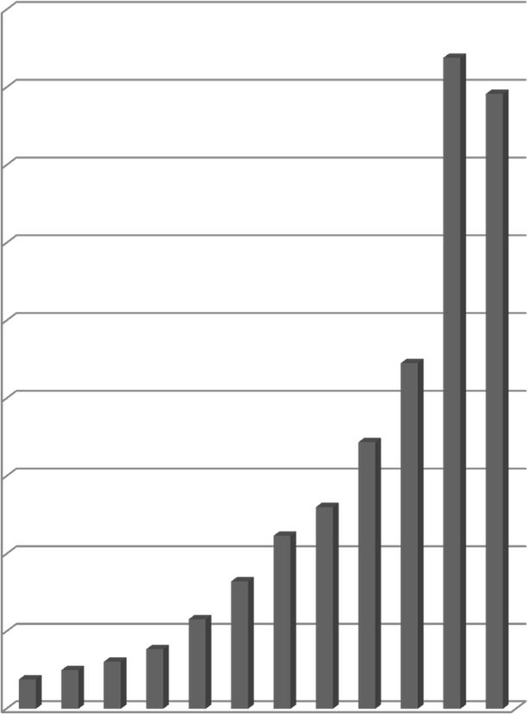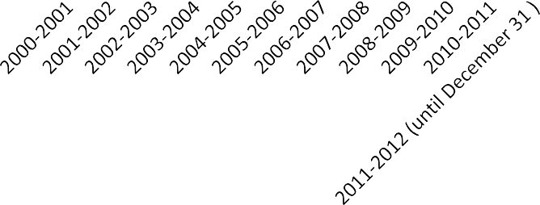

**Sales Revenue**

1800

1676.4

1583.4

1600

1400

1200

1000

891

800

687.6

600

In INR Million

520.8

447

400

329.4

231.6

200

76.2100.2121.8

154.2

0

*Source: Company files.*

(figu

**EXHIBIT 5: IT FINANCIALS**

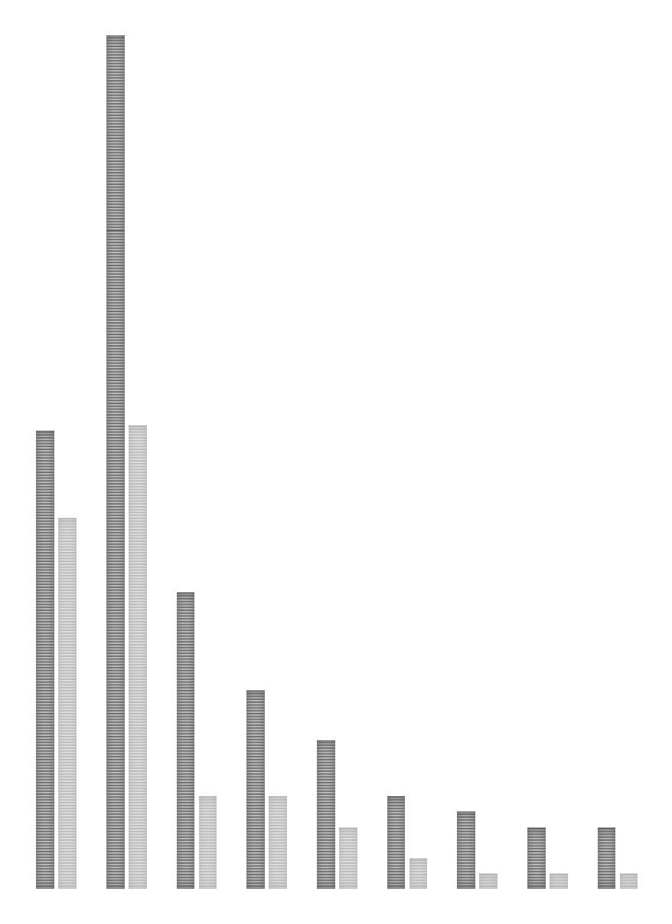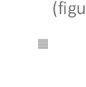

3000000

2760000

2500000

2000000

1500000

1500000

1483000

Hardware

res in INR)

Software (figures in INR)

1200000

1000000

960000

643000

500000

482000

300000 300000

301000

200000

250000

200000 200000

100000

50000 50000 50000

0

2011‐12 2010‐11 2009‐10 2008‐09 2007‐08 2006‐07 2005‐06 2004‐05 2003‐04

*Source: Company files.*